

MATHEMATICS 3CMAT/3DMAT SAMPLE EXAMINATION

RESOURCE-RICH
Section 7 of the New WACE Manual: General Information 2006–2009 outlines the policy on WACE examinations.

Further information about the WACE Examinations policy can be accessed from the Curriculum Council website at http://newwace.curriculum.wa.edu.au/pages/about_wace_manual.asp.

The purpose for providing a sample examination is to provide teachers with an example of how the course will be examined. Further fine tuning will be made to this sample in 2007 by the examination panel following consultation with teachers, measurement specialists and advice from the Assessment, Review and Moderation (ARM) panel.

The examination is in two parts, in line with recommendations of the ARM panel--a resource-free examination of 50 minutes, worth 40 marks, and a resource-rich examination of 100 minutes, worth 80 marks. CAS (Computer Algebra System) calculators are excluded in the resource-free part and included in the resource-rich part.

0000.doc




Western Australian Certificate of Education, Sample External Examination
Question/Answer Booklet

MATHEMATICS
3CMAT/3DMAT
Please place one of your student identification labels in this box.
WRITTEN PAPER
RESOURCE-RICH

Time allowed for this paper
Reading time before commencing work: Ten minutes
Working time for paper: One hour and forty minutes

Material required/recommended for this paper

To be completed by candidates

What kind(s) of calculator did you bring to this examination?

Make and model:
1.

2.
None  (tick if applicable)

To be provided by the supervisor
This Question/Answer Booklet

To be provided by the candidate
Standard items: Pens, pencils, eraser, correction fluid, ruler,
highlighter

Special items: Curriculum Council Mathematical Formulae and Statistical Tables Book, drawing instruments, templates, notes on TWO unfolded sheets of A4 paper and calculators satisfying the conditions set by the Curriculum Council for this subject.
Note: Personal copies of the Tables Book should not contain any handwritten or typewritten notes, symbols, signs, formulae or any other marks (including underlining and highlighting) except a name and address, and may be inspected during the examination.

Important note to candidates
No other items may be taken into the examination room. It is your responsibility to ensure that you do not have any unauthorised notes or other items of a non-personal nature in the examination room. If you have any unauthorised material with you, hand it to the supervisor before reading any further.

This paper is for students who have completed Units 3CMAT and 3DMAT as their last pair of units.
Structure of this paper

Working time | Number of questions available | Number of questions to be attempted | Marks
100 minutes | 11 | 11 | 80
 |  | [Total marks] | 80

This paper has ELEVEN (11) questions. Attempt ALL questions.

Question | Marks
1 | 5
2 | 6
3 | 7
4 | 6
5 | 6
6 | 7
7 | 5
8 | 5
9 | 7
10 | 12
11 | 14
Total marks | 80

Instructions to candidates

1. The rules for the conduct of Curriculum Council examinations are detailed in the Student Information Handbook. Sitting this examination implies that you agree to abide by these rules.

2. Write your answers in the spaces provided in this Question/Answer Booklet. Spare pages may be found at the end of the booklet. If you need to use them, indicate in the original answer space where the answer is continued (i.e. give the page number).

3. A blue or black ballpoint or ink pen should be used.

4. It is recommended that you do not use pencil except in diagrams.

5. Show all your working clearly. Your working should be in sufficient detail to allow your answers to be checked readily and for marks to be awarded for reasoning. Correct answers given without supporting reasoning may not be allocated full marks. Incorrect answers given without supporting reasoning cannot be allocated any marks. If you repeat an answer to any question, ensure that you cancel the answer you do not wish to have marked

6. On the front cover you are asked to state the kinds of calculator that you brought into the examination. This information is required to ensure the examination is fair for all students. Please complete the box. Note that the same marking procedure will apply to all scripts, whatever calculator you use.

THIS PAGE HAS BEEN LEFT BLANK INTENTIONALLY

RESOURCE-RICH

This paper has ELEVEN (11) questions. Attempt ALL questions.

Question 1 [5 marks]
There is a theorem called the Alternate Segment Theorem which says that the angle between the tangent and the chord at the point of contact is equal to the angle in the alternate segment. In the diagram below, x = y.

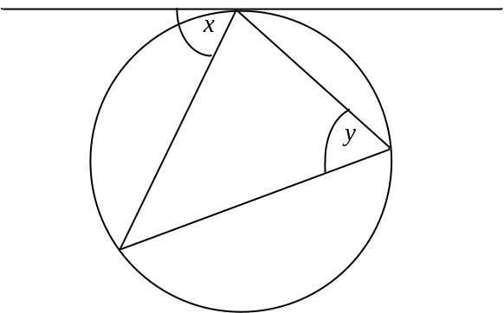

A student who was asked to prove the Alternate Segment Theorem gave this ‘proof’:

Since the Alternate Segment Theorem has to be true for all triangles, it has to be true when one side of the triangle is the diameter of the circle.

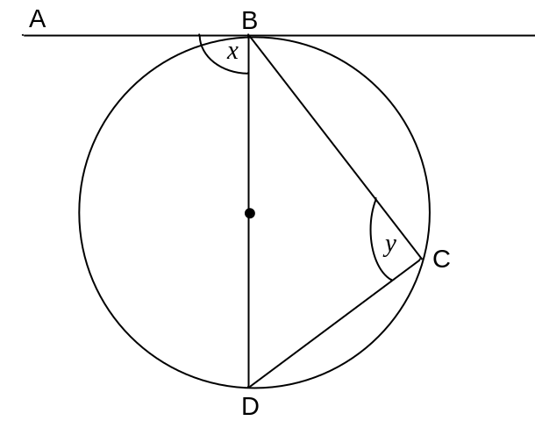
∠ABD = 90° (angle between a radius and a tangent)
∴ x = 90°
∠BCD = 90° (angle in a semicircle)
y = 90°
and x = y

- Discuss the validity of the student’s proof.
[2 marks]

- The diagram below shows an isosceles triangle BED, its circumcircle and tangent at one vertex B. ∠ABD = x and ∠CBE = y.

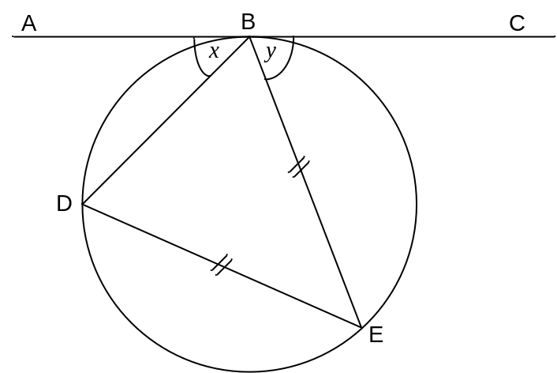

Prove that 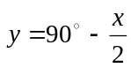
[3 marks]

Question 2 [6 marks]
Events A and B are such that P(A) = 0.45, P(B) = 0.52 and P(A ∪ B) = 0.736

- Evaluate
(i) P(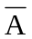)
[1 mark]

(ii) P(A ∩ B)
[2 marks]

(iii) P(B|)
[1 mark]

- Determine whether or not events A and B are independent.
[2 marks]

Question 3 [7 marks]
An experiment involves rolling a fair die and when 6 is on the uppermost face the outcome is called a ‘success’. If the random variable X represents the number of successes when the die is rolled 48 times, calculate:

- the expected mean value for X.
[1 mark]

- the expected standard deviation for X.
[1 mark]

- As part of exploring the outcomes of the above experiment, Mr Brown asks each student in his class of 30 to roll a die 48 times. He records the number of successes for each student, and calculates the mean number of successes. The class repeats this exercise 10 times.

Sketch a graph showing the distribution that you would expect for the 10 mean values.
[2 marks]

- Ms Smith’s class of 15 students explores the same experiment—each student rolls a die 48 times, Ms Smith records the number of successes for each student and calculates the mean number of successes. Ms Smith’s class repeats the exercise 10 times.

Compare and contrast the distribution of mean values that you would expect for Ms Smith’s and Mr Brown’s classes.
[3 marks]

Question 4 [6 marks]
An object moves along a straight line for a period of k seconds. The graph of its velocity, v m/s, as a function of time, t seconds, is shown in the diagram.

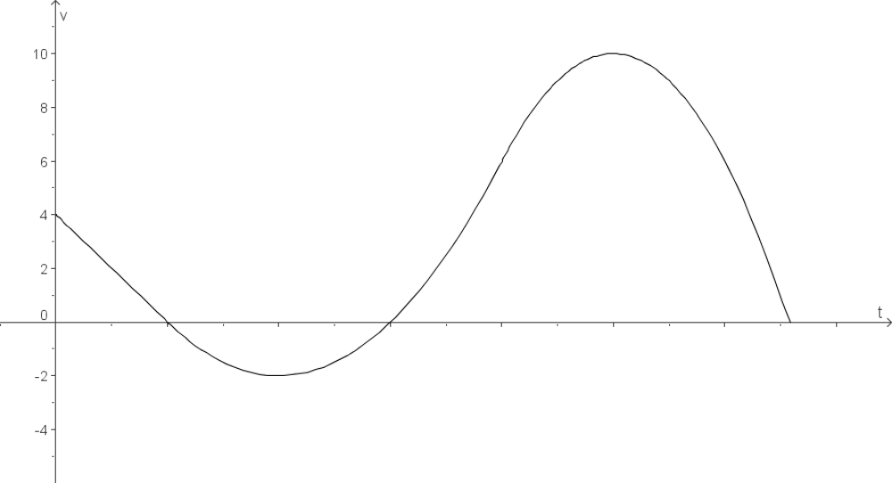
(k,0)
(6,0)
(2,0)
Given, 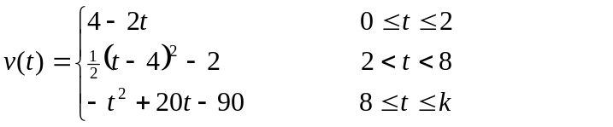

Determine:

- k
[1 mark]

- the distance travelled by the object in the first 8 seconds.
[3 marks]

- the time(s) at which the acceleration of the object is 0 m/s².
[2 marks]

THIS SPACE HAS BEEN LEFT BLANK INTENTIONALLY

Question 5 [6 marks]
A spherical metal ball of radius 4 cm is coated with a layer of ice of uniform thickness. The ice is melting such that when the ice is 6 cm thick, the thickness of the ice is decreasing at the rate of 0.008 cm/h.

When the ice is 6 cm thick, calculate the rate at which the volume of the ice is decreasing.
[6 marks]

THIS PAGE HAS BEEN LEFT BLANK INTENTIONALLY

Question 6 [7 marks]
The graph below shows the median monthly on-peak and off-peak energy consumption rates in kilowatts per month at an industrial site in the 1990s.
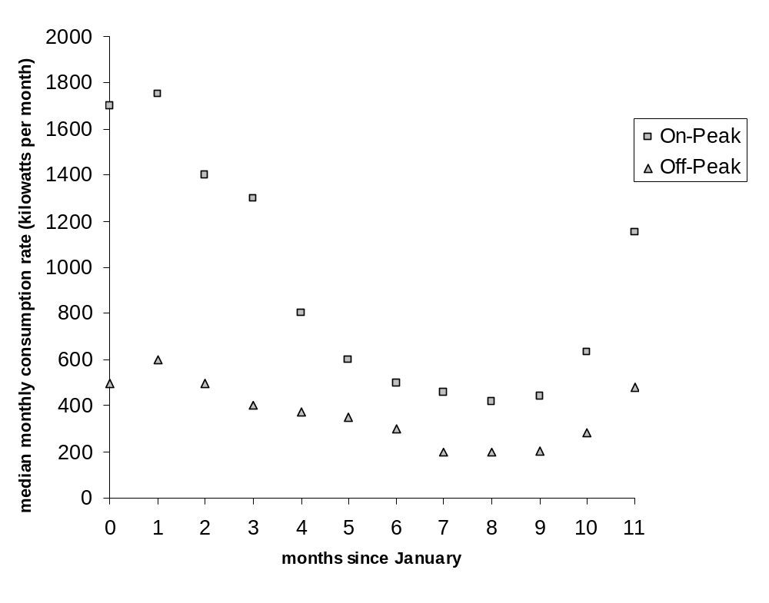
- Which month had the greatest median monthly on-peak energy consumption rate in the 1990s?
[1 mark]

- Which two consecutive months produced the largest decrease in median monthly on-peak energy consumption rate in the 1990s?
[1 mark]

Let t be the number of months since January.

The median monthly on-peak energy consumption rate in the 1990s, , can be modelled by
for 0 ≤ t ≤ 11.

The median monthly off-peak energy consumption rate in the 1990s, 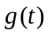, can be modelled by
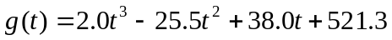 for 0 ≤ t ≤ 11.

- (i) Write an expression which would give the area between the graphs of 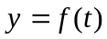 and
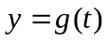 for 0 ≤ t ≤ 11.
[2 marks]

(ii) Find the area between the graphs of and for 0 ≤ t ≤ 11.
Give your answer correct to five significant figures.
[1 mark]

(iii) Interpret the area between the graphs of 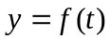 and for 0 ≤ t ≤ 11.
[2 marks]

Question 7 [5 marks]
A workshop recorded the volume of oil removed from the most recent 120 cars serviced. The mean volume was 4.44 L and standard deviation 0.80 L. The lower quartile was 3.72 L, median 4.40 L, and upper quartile 5.12 L. Examine these statistics and make and justify a conclusion about whether or not the variable is normally distributed.
[5 marks]

Question 8 [5 marks]
A new drug is claimed to improve the hand-eye coordination of children. In order to test the drug, ten children who suffer hand–eye coordination difficulties participated in a six-week study. An appropriate study design was used which included measuring hand–eye coordination with a standard test.

The manager of the study recognises that improvement on a test could be due to the drug or due to chance alone and that the probability of any one child improving their score by chance alone is 0.5. Hence, the manager decides to accept that the drug improves hand–eye coordination only if the probability that the results could have been produced by chance alone is less than 10%.

- Use your knowledge of the binomial distribution to find the probability that eight or more children would show improvement by chance alone.
[3 marks]

- If eight or more children show improvement, would the manager conclude that the drug improves hand-eye coordination, using his 10% criterion? Explain.
[2 marks]

Question 9 [7 marks]
Zaki likes to add consecutive numbers together, for example 7 + 8 + 9 = 24. When Zaki adds three consecutive numbers together, the sum always appears to be divisible by 3. This does not surprise Zaki, because he realises that if the first of the three numbers is x, then

x + (x + 1) + (x + 2)

= 3x + 3

= 3(x + 1) which is divisible by 3.

- Use algebra to show that the sum of five consecutive numbers is divisible by 5.
[1 mark]

- Zaki continued to add consecutive numbers and summarised his results in a table:

n | Sum of n consecutive numbers, starting at x
3 | 3x + 3
4 | 4x + 6
5 | 5x + 10
6 | 6x + 15
7 | 7x + 21

On the basis of the table Zaki conjectured that:

The sum of n consecutive numbers:
- is divisible by n for odd values of n and
- is not divisible by n for even values of n.

Zaki also recognised from the table that he could write a formula for ‘the sum of n consecutive numbers starting at x’. He used the facts that:
- 1, 3, 6, 10, 15, 21… are triangular numbers, T1 = 1, T2 = 3, T3 = 6 . . . .
- the nth triangle number can be calculated using Tn = 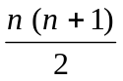

(i) Write a formula for the sum of n consecutive numbers starting at x.
[2 marks]

(ii) Using algebra and the formula that you wrote in (i) above, prove Zaki’s conjecture.
[4 marks]

Question 10 [12 marks]
The graph of 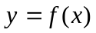, where 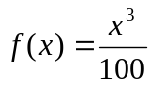, x > 0, is shown below.
The tangent to at x = 5 is also shown.
y
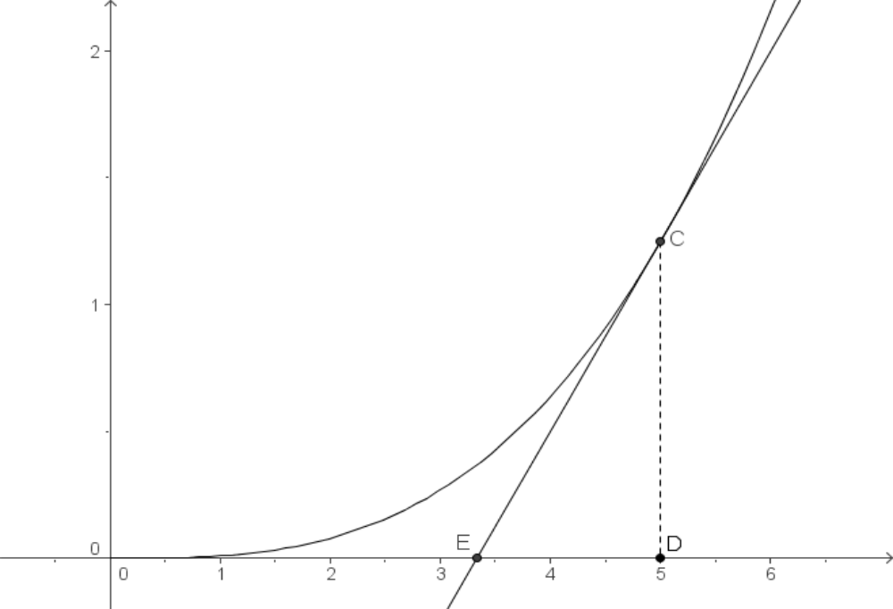
x

- Find 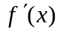.
[1 mark]

- Find the equation of the tangent to at x = 5.
[3 marks]

- The tangent to at x = 5 intersects the x-axis at E and the right-angled triangle CDE may be drawn, as shown in the diagram.
Find the exact length of ED.
[2 marks]

An infinite number of tangents to can be drawn. Each tangent forms a right-angled triangle CDE, where E is the x-axis intercept.

Jason investigates the tangents at x = 1, x = 3 and x = 12. His findings are summarised in the table below:

x | Length of ED
1 | 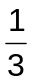
3 | 1
12 | 4

- (i) Using Jason’s findings, make a conjecture about the value of the length of ED for the tangent to at x = k in terms of k.
[1 mark]

(ii) By considering the tangent at x = k, prove the conjecture you made in part (d)(i).
[5 marks]

Question 11 [14 marks]
The golf balls purchased by the Seaviews Golf Club must meet a set of standards in order to be used in professional tournaments held at this golf club. One of these standards is the distance travelled. When a ball is hit by a mechanical device with a 10-degree angle of launch, a backspin of 42 revolutions per second, and a ball velocity of 72 metres per second, the distance the ball travels may not exceed 266.3 metres. Manufacturers want to develop balls that will travel as close to the 266.3 metres as possible without exceeding that distance.

A particular manufacturer that wishes to supply golf balls to the Seaviews Golf Club has determined that the distances travelled for the balls it produces are normally distributed with a standard deviation of 2.56 metres. This manufacturer has a new process that allows it to set the mean distance the ball will travel.

- If the manufacturer sets the mean distance travelled to be equal to 263 metres, what is the probability that a ball that is randomly selected for testing will travel too far?
[2 marks]

- Assume the mean distance travelled is 263 metres and that five balls are independently tested. What is the probability that at least one of the five balls will exceed the maximum distance of 266.3 metres?
[2 marks]

- If the manufacturer wants to be 99 percent certain that a randomly selected ball will not exceed the maximum distance of 266.3 metres, what is the largest mean that can be used in the manufacturing process?
[2 marks]

The secretary of the Seaviews Golf Club visits the manufacturer and is assured that the mean distance travelled by their golf balls is 263 metres. He makes a random selection of 64 golf balls.

- If the sample mean is 262.8 metres, determine a 99% confidence interval for the mean distance travelled by the golf balls.
[3 marks]

- Determine the probability that the sample mean will lie between 262.5 metres and 263.5 metres.
[3 marks]

- How large a sample should the manufacturer use to be 95 percent sure that the sample mean is within 1 metre of 263 metres?
[2 marks]

ACKNOWLEDGEMENTS

Published by the Curriculum Council of Western Australia
27 Walters Drive
OSBORNE PARK WA 6017

